write any research or decisions with dates attached:

**4/12/18**

Dimensions:

Width: ~490 cm

Length: ~490 cm

Height: ~815 cm

Research types of dispensing mechanism

Dispensing Mechanism to be used

* Cans will be stored horizontally in the storage unit
* Cans will roll down to the elevating unit, and then lift to the top of the vending machine via the scissor lift mechanism

Find what needs to be stocked in vending machine (ask either Ben)

* 4 types of can - 5 for each type but will be good to have more (Restraint of the refrigerating unit)

Determine what dispensing mechanism is best for what needs to be stocked.

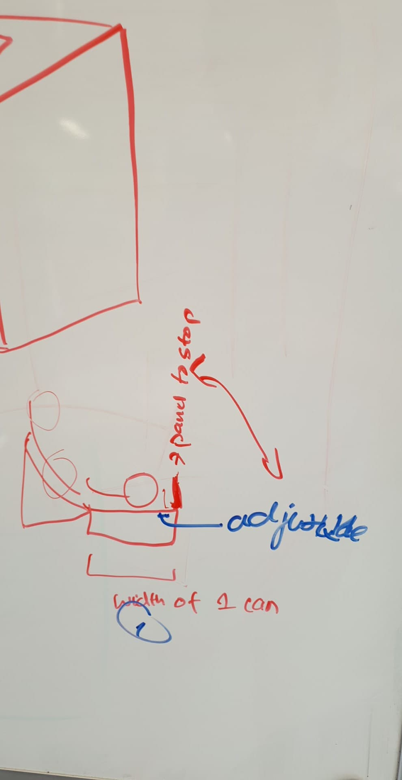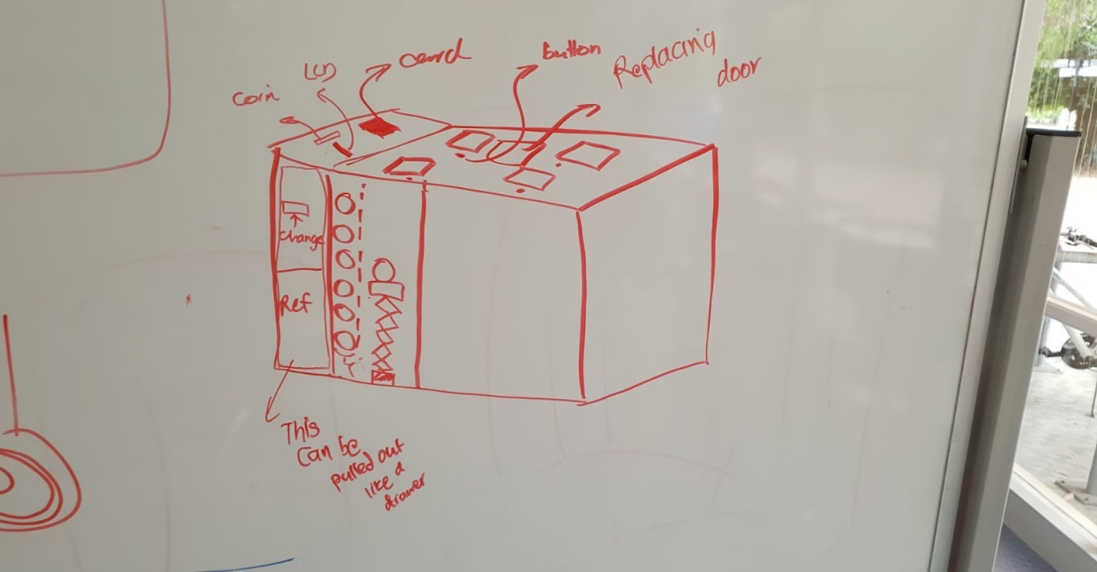

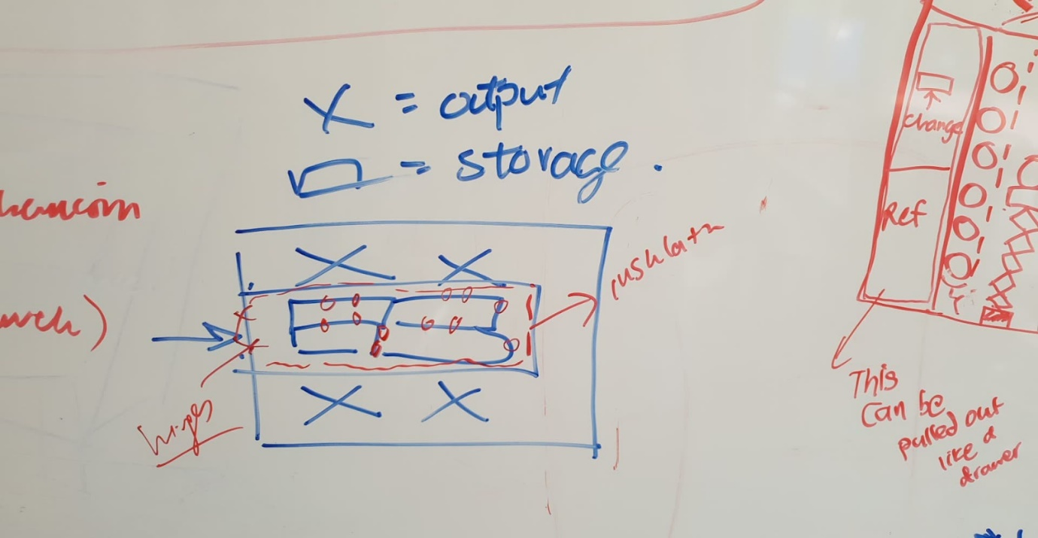

Draft Material List

1. Buttons
2. Frame (Laser cut) - MDF
3. Insulation (research material) - PU rigid foam
4. Coin (check machine)
   1. <https://www.instructables.com/id/Make-Money-with-Arduino/>
   2. <https://www.youtube.com/watch?v=yIFst9fgcXQ&feature=youtu.be>
5. Arduino mega
6. Card (Rfid)
7. Refrigeration (research)
8. <https://www.youtube.com/watch?v=Z77kgVoqKeE>
9. <https://www.youtube.com/watch?v=dW3cEnoAf6I>
10. <https://www.aliexpress.com/item/1Pc-240W-Semiconductor-Refrigeration-Unit-Air-Condition-Machine-Core-Water-Cooled-Device-Car-Micro-Air-Cooling/32921706536.html?spm=2114.search0104.3.1.1d75161fmBeMOV&ws_ab_test=searchweb0_0,searchweb201602_1_10065_10068_10130_10547_319_317_10548_10696_453_10084_454_10083_10618_10307_537_536_10131_10132_10133_10059_10884_10887_100031_321_322_10103,searchweb201603_51,ppcSwitch_0&algo_expid=5cc6a81b-9a6a-41cb-ad43-b2e5b43f0fd4-0&algo_pvid=5cc6a81b-9a6a-41cb-ad43-b2e5b43f0fd4>
11. <https://www.youtube.com/watch?v=clZsykBt4YA>
12. Thermoelectric Refrigeration Unit
    1. <https://www.aliexpress.com/item/Thermoelectric-Peltier-Refrigeration-Cooling-System-Kit-Cooler-2-x-Double-Fan-DIY-New/32763626725.html>
    2. https://www.youtube.com/watch?v=jCMDuTR-mqY
13. Screws
14. Rod (metal)
15. Acrylic
16. Drawer slides
17. Platform (lift)
18. Retraction unit (research)
19. Electrical power unit
20. Dispenser pipe

**6/12/18**

Developments:

1. Lead screw system was discussed as opposed to scissor lift

<https://www.youtube.com/watch?v=kaJVWoKj2a4>

1. Rethinking of entire model based on using an old refrigerator.

Compressor 15 cm deep x 17 cm tall

58 cm tall

11/12/18 Dispensing mechanism: <https://www.youtube.com/watch?v=7gW1hmYqdwo>

**2/1/2019**

Progress:

1. Further research on refrigeration system

Components required:

1. Peltier Unit
2. Radiator (Fan and heat sink)
3. Cooler water exchanger
4. Water Block
5. Water Pump

Theory

1. Using water pump to pump the water from the water box into the heat exchanger
2. The exchanger will be mounted on the cold side of the peltier device, while the hot side will be connected to the radiator via heat pipes
3. Cooled water will be coming out of the exchanger, and flow back to the water box to create a water cycle

Improvements made

1. Connecting the peltier device to the radiator via heat pipes
   1. Heat will dissipate much more effectively
   2. Reference:
      1. <https://www.youtube.com/watch?v=C-_CgFnj-rM>
      2. <https://www.youtube.com/watch?v=8JIrQbBFWlo>
      3. <https://www.youtube.com/watch?v=-QL9cSgh9pA> (But including water loop)
2. Created framing of the vending machine on solidwork

<https://tetech.com/peltier-thermoelectric-cooler-module-calculator/?mode=1&dtmax=75&heatLoad=470&hotSideTemp=50&coldSideTemp=25&potted=0&emailsent=0>

Things to do

1. Order and test Peltier system Jan 10th

-Jaycar:

1. 68W $28
2. 33W $22
3. 51 $25

* TEC12706 50-57 W from roughly $2 alibaba not counting shipping- multiple links
* 2 pc TEC12710 85-96 W $27 nc shipping <https://www.u-buy.com.au/search/index/view/product/B072TQX2RQ/s/2-pcs-TEC1-12710-Thermoelectric-Peltier-Cooler-12V-100W-154Wmax/store/store/kk/dp>
* TEC12730 350W $47 AUD with 10-18 days shipping

<https://www.aliexpress.com/store/product/TEC1-12730-Heatsink-Thermoelectric-Cooler-Peltier-Cooling-Plate-12V-30A-Refrigeration-Module/1966502_32705026399.html>

<https://www.u-buy.com.au/catalog/product/view/id/1892818?gclid=EAIaIQobChMItOjz-YjR3wIVRbaWCh2BZQ7qEAYYASABEgLhEfD_BwE>

* <https://rainbowsemi.en.alibaba.com/product/60553198084-804203620/TEC1_12730_62_62mm_Thermoelectric_Peltier_Cooler_peltier_thermoelectric_cooler.html?spm=a2700.icbuShop.41413.24.389541b4TJQpnu> $14-$17.53 without shipping

<http://peltiermodules.com/?p=product>

1. Creating dispensing mechanism

* Pvc pipe (scrap yard?)
* Motors x4
* Padding and ramp

1. Lead Screw lift

* Screw
* Motor
* Brackets, screws, washers, bolts
* Drawer slides
* Frame

1. Insulation - Jan 9th Future foam
2. Order coin acceptor - after Jan 10th

-CH 926 can accept Australian $2 coins in thickness and diameter

1. Copper pipes and Aluminium boards section

roughly 9 meters of pipe needed if diameter = 10mm 25-30 meters if diameter = .5 inch.

    7) Work out coin storage (drawer slides)  and possibility of change

     8) Dispensing gates

**3/1/2019**

Bill of Materials- Vending Machine

Materials to be bought online from Ebay

1) Peltier System: <https://www.ebay.com.au/itm/MODULE-COOLER-TEC1-12710-PELTIER-154W-K2B8/283157435042?epid=1282393713&hash=item41ed7f92a2:g:LTgAAOSw6j1bmgME:rk:3:pf:0#shpCntId>

Qmax = 100 W

Size 40x40x3.3 mm

Cost: $10.53 AUD

Quantity: 2

Shipping: Free between 14 Jan - 21 Jan

Total: $21.06

2) Aluminium Water Cooling Block: <https://www.ebay.com.au/itm/41-122-Water-Cooling-Heatsink-Block-Waterblock-Liquid-Cooler-For-CPU-GPU-TT/273571637837?epid=931457295&hash=item3fb223ea4d:g:xEcAAOSwwo1XclEs>

Size: 41 x 122 x 12 mm

The external diameter of the connector is 9.5mm

The inner diameter of the connector is 6-8mm

Cost: $9.82 AUD

Quantity: 1

Shipping: Free between 14 Jan - 21 Jan

Total: $9.82

3) Copper Coil Tubing: <https://www.ebay.com.au/itm/1-2-1-4-3-4-3-8-Copper-Pipe-Sizes-R410A-5m-10m-15m-Copper-Coil-Tubing/192599909381?hash=item2cd7d96405:m:mnGi9m0h9S97L8Dw_oIZ8Kw:rk:24:pf:0>

Size: 15 meters

Outside diameter: 3/8 inch = 9.53 mm

Wall thickness: 0.81

Internal diameter = 7.88 mm

Cost: $61 AUD

Quantity: 1

Shipping: Free between 14 Jan - 21 Jan

Total: $61 AUD

Total bill: $91.88 = $92

* Diameter of Water pump is approx. 9mm

Components for Lead screw lift:

-) 2 metal rods - purchased from Scrap yard

-) Stepper Motor Nema 17

-) T8 Lead screw 1000mm

-) Lead screw coupler: 8-5mm

-) Ball screw x 2

-)

Coin Acceptor: <https://core-electronics.com.au/coin-acceptor-programmable-3-coin-types.html>

<https://www.ebay.com.au/p/Multi-Coin-Acceptor-Selector-Mechanism-for-Arcade-Video-Gaming-Machine-Ac895/3016031698?iid=263982916995&chn=ps>